~WELCOME TO THE SNUGGLER’S ROOM~
(SNUGGLERS ARE APPROXIMATELY 8 WEEKS TO 1 YEAR OLD)
The staff will sign your child/children in on and out each day. In order to relay daily information accurately please write down and put it in their bag for the staff to read once in the classroom. Important information to include would be how they slept the night before, what time they woke up and when (as well as what if it is pertinent) they ate last. Other such information may include- someone new is picking the child up, child is getting picked up early, child is teething, child didn’t sleep well, and/or child will need medicine. Please let us know of any changes in your child’s schedule. If there is a change, it is helpful if you write it down for us or email it in advance.
We provide a tub for each child. In this tub we will keep things your child needs during the course of his or her stay with us. Items to consider leaving with us may include – diapers, extra clothes, diaper rash cream, extra bottles, extra pacifier, extra sippy cup, and items for comforting. If you are using cloth diapers please provide a wet/dry bag to be sent home everyday. We will not be able to clean or rinse dirty clothes or cloth diapers. They will be sent home dirty in a plastic bag. PLEASE label everything!!
If your child is eating food, items should be brought in a hard plastic container, wet/dry bag or a sealable plastic bag (such as a ziploc gallon size bag) any of which should have your child’s name written on it. Please do not use insulated lunch boxes or bags. They will immediately be placed in the classroom refrigerator upon arrival. There is no need to send in an ice pack. Please label all items – spoons, plastic containers and cups. It helps eliminate any confusion during lunch and snack times about what items need to be sent home with which child. We do have a microwave to heat up food items. We have a bottle warmer for bottles. We have a freezer for frozen breast milk – you must label with – name, amount and date on each bag. Bottles prepared at home must be labeled with the child’s name, date and time made. The same goes for frozen baby food. You may also bring in food items to leave at school such as puffs, cereal, formula and jar food – please label all with the child’s name.
We follow the safe sleep practices required for us to maintain our unlicensed ministry status with the state of Indiana. This means that we are NOT able to do the following – put any items in the crib with your baby other than a pacifier (the pacifier may not be attached to anything – no straps, blankets or animals). We must lay your baby on their back and keep them there until they are able to easily roll over from both tummy to back and back to tummy. They must sleep in a crib. If they are brought in asleep in their car seat we are required to remove them and put them in a bed. We cannot allow them to sleep in any kind of bouncer or swing. Likewise, we cannot elevate the mattress or use any kind or wedge in the crib – unless we have a note from the Doctor on a state provided form. I can provide one to you anytime you feel -that due to medical reasons, an alternate sleep position is necessary.
If someone other than you will pick up your child, we will need a written note or email giving us permission to send your child home with them. Even if it is a parent of the child, if we have not met them, we will not send the child home with them without out a written note and a picture ID.
If your child should need to take medicine during the day, you will need to fill out a medical form allowing us to administer the medicine.

Once your child is nearing their first birthday, we will work with you to help them transition to the Crawler Room class schedule. It is helpful if at this time they are using a cup and eating finger foods.
- 1:00 nap
- 3:30 afternoon snack
- 9:45 morning snack
- 10:15 morning nap if needed
- 12:00 lunch

Please email Rachel Stults at faithutheranps@gmail.com for any questions or concerns regarding this document.

If you need to contact Rachel Stults during the day, text is preferred.
You may text me at any time at 812-322-2576

We look forward to meeting you and your little one!

Blessings,

Rachel Stults
Director

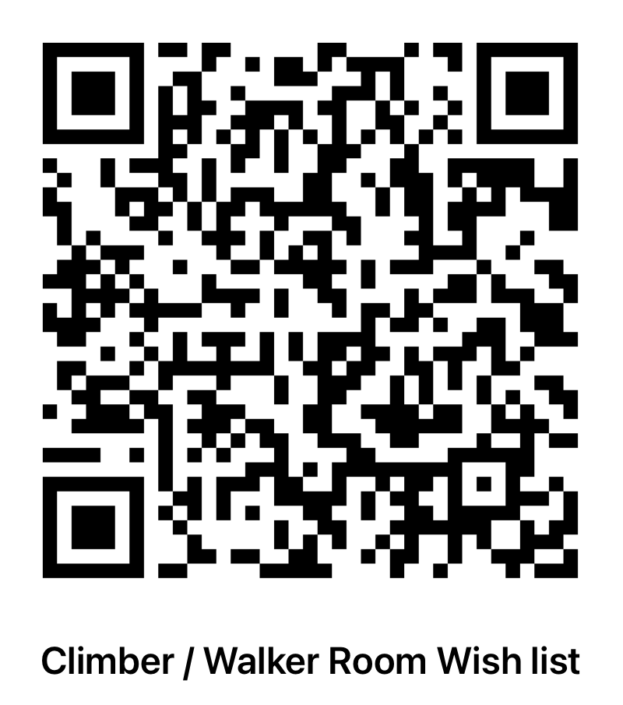
Snugglers too

